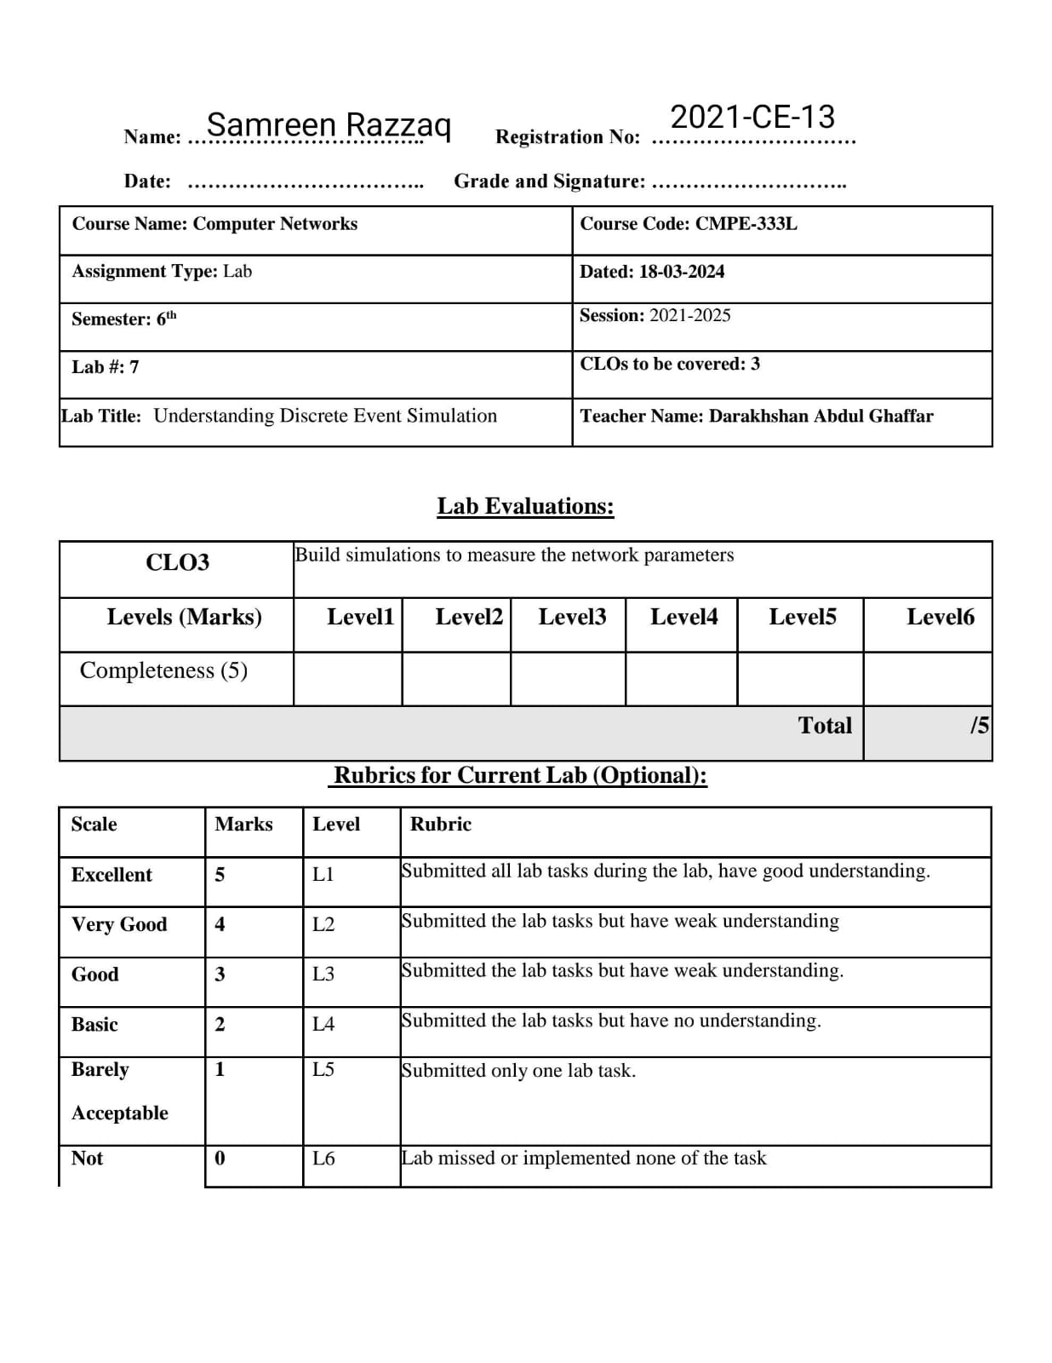

Lab Tasks:

Exercise 1

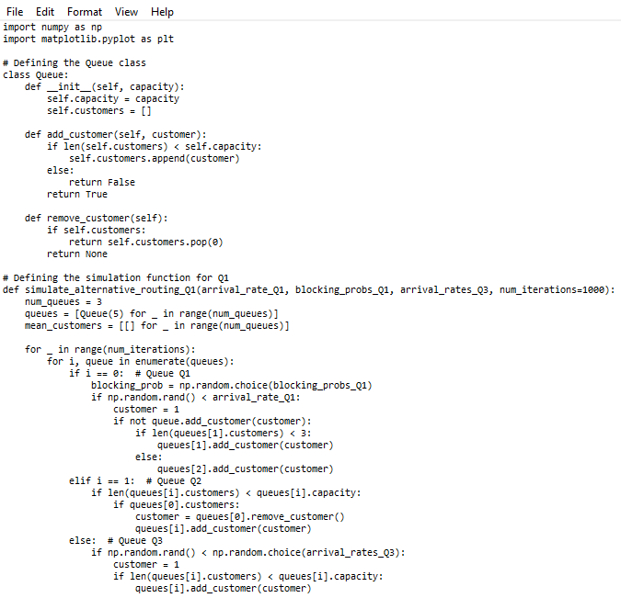Alternative routing problem: simulate the following network of queues, all queues have equal capacity, departures of first queue is fed to the Q2 until it is filled upto threshold = 3 after that remaining customers are routed to the Q3, use the simulation program to find out the mean customers in all three queues for different arrival rates and blocking probability of Q1 and Q3.

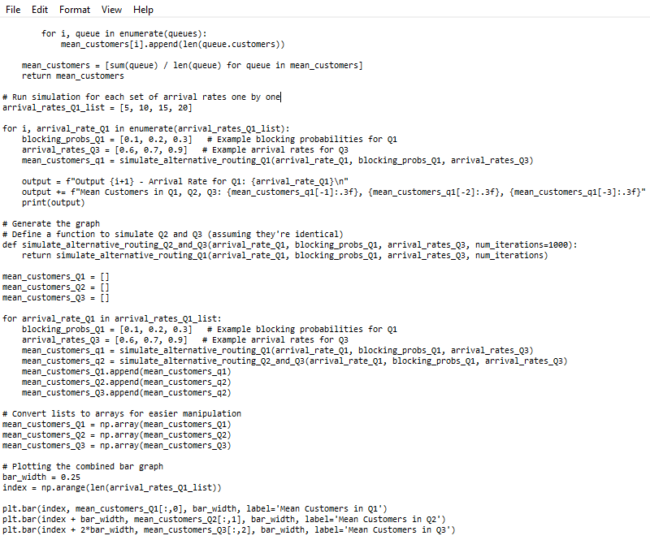

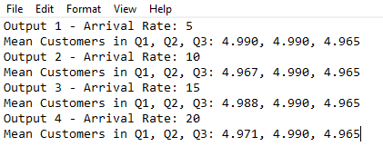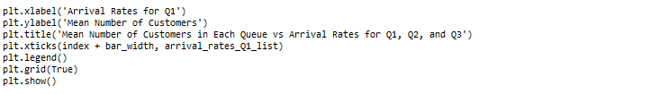**Output:**

**Chart:**

